General
Is merging only performed if there is a gap between neighboring fields, or is it done in all cases?

Split Segment
Where does data from new segment(s) come from?

Case #1) Segment contained within boundaries of gloss/ref.
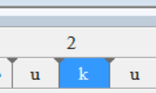
Do we split ref? If so, how is ref renumbered?

Case #2) Segment on ending boundary of gloss/ref.
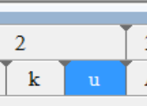
Do we split ref? If so, how is ref renumbered?
If gloss/ref/glossnat does not exist, should it be created?

Case #3) Segment matches gloss/ref segment size
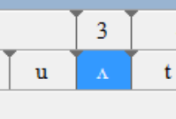
Do we split ref? If so, how is ref renumbered?

Case #4) Segment is not contained with gloss/ref/gloss nat segment
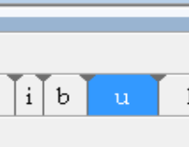
Do we create new gloss/ref/gloss nat segment?

Merge Segments
Do we really want to delete existing phonetic/phonemic/ortho data?

Case #1) Segment on beginning boundary of gloss/ref.
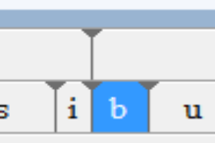
Is ref/gloss segment to left merged?

Case #3) Segment matches gloss/ref segment size
Is ref/gloss segment to left merged?

